**IG Samples Browser Templates**

Contents

Introduction 2

Types of Templates 2

Installation of Templates 2

Usage of Templates 3

Section A – If neither SL or WPF samples project exists 4

Section B – If SL samples project already exists and WPF project needs to be created. 7

Section C – If WPF samples project already exists and SL project needs to be created. 12

Section D – If a new sample needs to be added to the existing IG samples project 12

History 13

# Introduction

This document explains how to use IG Samples Browser Templates to create IG sample projects and IG samples’ pages for SL/WPF Sample Browsers.

# Types of Templates

The following table lists all available templates for IG samples and as well as their purpose.

|  |  |  |
| --- | --- | --- |
| Template Name | Template Type | Description |
| IG Samples Browser Project (WPF) | Project Template | Creates a new IG Samples Browser project (WPF class library) for WPF Sample Browser |
| IG Sample Browser Project (SL) | Project Template | Creates a new IG Samples Browser project (SL application) for SL Sample Browser |
| IG Sample Browser Page | Item Template | Creates a new IG Sample Browser Page for XAML Samples Browser. This page can be used in SL and WPF Samples Browsers. |

# Installation of Templates

Follow these steps to install and add IG Samples Templates to Visual Studio 2010

1. Navigate to the following directory in TFS Source Control Explorer

$/NetAdvantage/DEV/XAML/2013.1/Samples/XAML/Infragistics.Templates.SamplesPackage/Install

1. Get the latest source and open the directory in Windows Explorer
2. Install VS Extension package: **Infragistics.SamplesBrowser.Templates.vsix**
3. Restart VS

# Usage of Templates

This section provides instructions on how to use IG Samples Templates to create new IG samples. They must be followed as they are listed in order to preserve the structure of the XAML Sample Browser and enable code sharing between SL/WPF Sample Browsers.

Note: These instructions could be simplified if IG Samples Projects Templates had custom wizards for creating project files in destination folders instead of project subfolders.

1. Open one of the following VS solutions:

* Infragistics.Samples.SL.sln
* Infragistics.Samples.WPF.sln

1. In TFS Source Control Explorer, navigate to the location of the XAML Sample Browsers:

$/NetAdvantage/DEV/XAML/2013.1/Samples/XAML

1. Check if a IG samples project already exists in TFS for a IG component/control:

## Section A – If neither SL or WPF samples project exists

1. Select **File – Add – New Project…** menu item
2. Under **Installed Templates** tree node, select appropriate IG Samples Project depending on the opened Sample Browser:

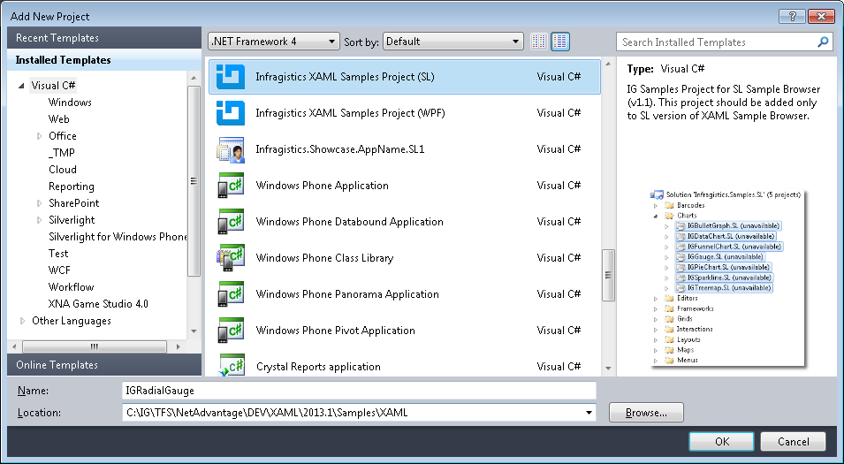

1. Type a name for the new project using the following naming convention: **IG<ComponentName>**

Note: Do not add either “**.SL**” or “**.WPF**” to the project name at this point (see step 6)

|  |  |
| --- | --- |
| IG Component Name | IG Samples Project Name |
| XamDataChart | IGDataChart |
| Resource Washer | IGResourceWasher |

1. Make sure that the project location points to this folder:

…\NetAdvantage\DEV\XAML\2012.1\Samples\XAML

1. Click the **OK** button to generate a new IG samples project in opened VS solution.
2. In New Slivlerlight Application dialog, select the following options:

* Check **Host the Silverlight application…** and select **Infragsitcs.Samples** project
* Select **Silverlight 5** or newer version
* Uncheck **Add a test page…**
* Check **Enable Silverlight debugging…**

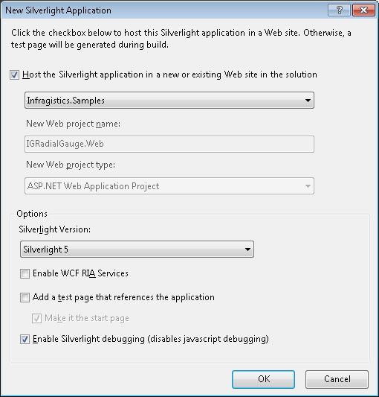

1. In Solution Explorer, located newly created project and append “**.SL**” to its name.

Note: Do not change assembly name or default namespace.

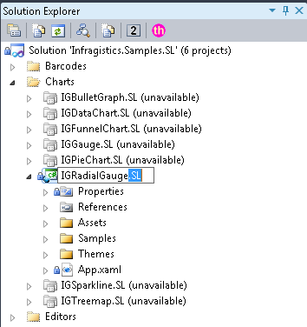

1. Save and check-in the VS solution to TFS when done creating IG samples projects.

## Section B – If SL samples project already exists and WPF project needs to be created.

1. Select **File – Add – New Project…** menu item
2. Under **Installed Templates** tree node, select **IG Samples Project for WPF Sample Browser**:

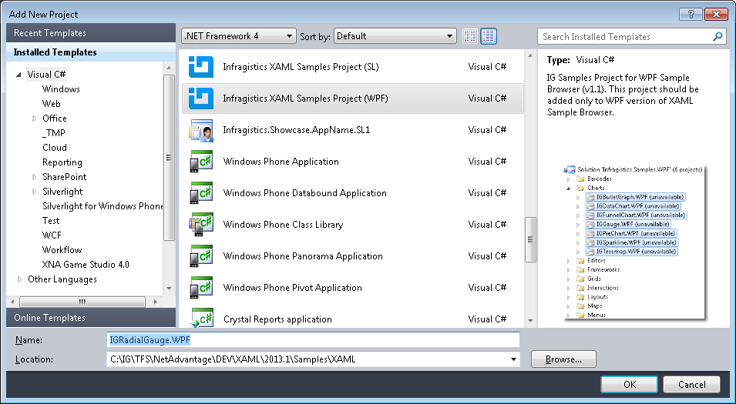

1. Type a name for the new project using the following naming convention: **IG<ComponentName>.WPF**

**Note:** Include “.WPF” at the end of project name.

|  |  |
| --- | --- |
| IG Component Name | IG Samples Project Name |
| XamDataChart | IGDataChart.WPF |
| Resource Washer | IGResourceWasher.WPF |

1. Click OK button and then Open Properties page of the newly created project.
2. Remove “**.WPF**” from the Assembly Name and Default Namespace fields:

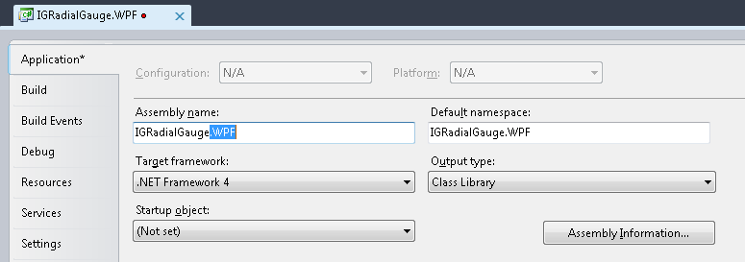

1. Right click the “**.WPF.csproj”** project and select **Open Folder in Windows Explorer** menu item.
2. In Solution Explorer, unload and then remove the “**.WPF.csproj”** project
3. Save the whole solution.
4. In Windows Explorer, copy the “**.WPF.csproj”** project and “**.WPF.csproj.vspscc”** files.
5. Navigate up one level, open **IG<ComponentName>** folder, and paste the project file

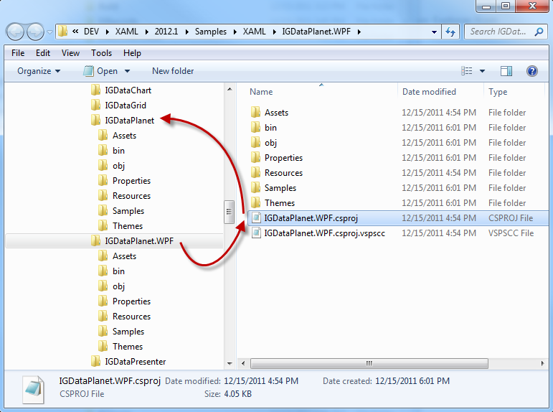

1. In TFS Source Control Explorer, undo pending changes to **IG<ComponentName>.WPF** folder.

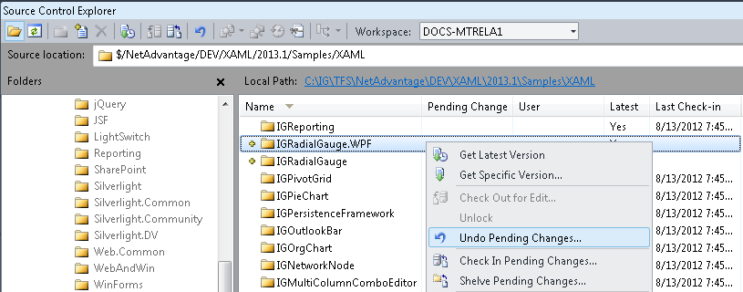

1. In Solution Explorer, select **File – Add – Existing Project…**
2. Navigate to the copied project ( **.WPF.csproj** ) in step 10
3. Click on the **Open** button to load the project to VS solution.
4. Add **IG<ComponentName>.WPF** asa project reference to **Infragistics.SamplesBrowser.WPF** project.

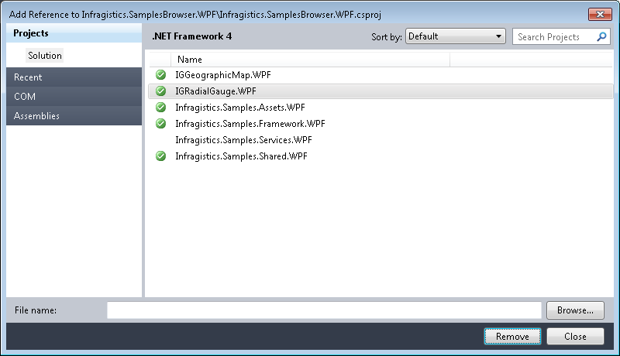

1. In Source Control Explorer, add the following two files in **IG<ComponentName>**folder:

* **IG<ComponentName>.WPF.csproj**
* **IG<ComponentName>.WPF.csproj.vsoscc**

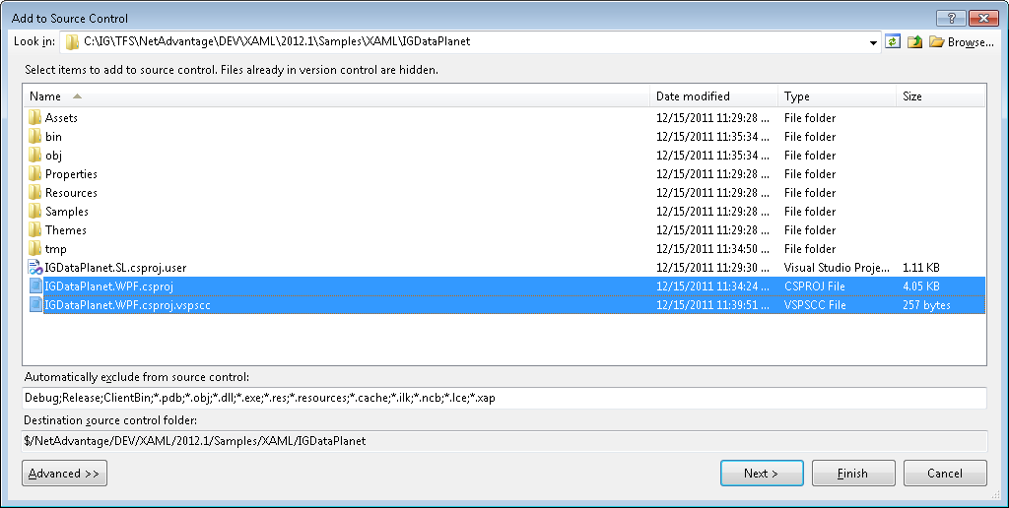

1. Save and check-in the VS solution in TFS.

## Section C – If WPF samples project already exists and SL project needs to be created.

1. Repeat all steps from section B with substituting “.WPF” with “.SL”.

## Section D – If a new sample needs to be added to the existing IG samples project

This section should be followed when adding samples that can be shared between SL/WPF Sample Browsers.

1. In Solution Explorer, navigate to a location where a new sample should be located:

For example: IGDataChart (project) – Samples (folder) – Data (folder)

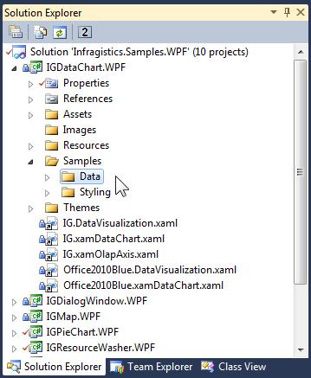

1. Select **Add – New Item…** from the right-click menu.
2. Select **IG Samples Browser Page** item under Installed Templates – Visual C# tree node:

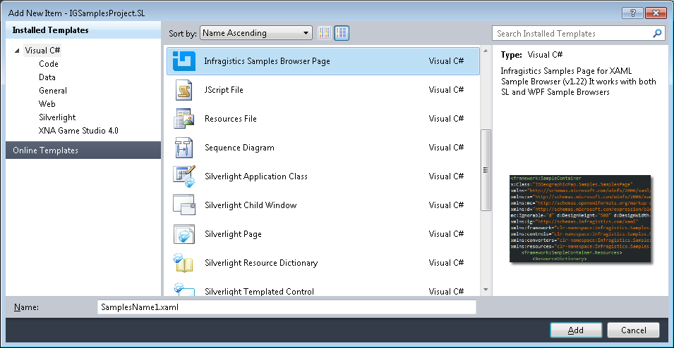

1. Type a name for the sample and click on the Add button.
2. Implement the sample and check it in.

# History

|  |  |
| --- | --- |
| Version | Changes |
| 0.1 | MT- Initial Draft |
| 0.2 | MT - Updated section with instructions for Installation and Usage of templates |